AtLease - Blockchain based Decentralised Warehouse Leasing

Abhishek Biradar, Piyush Mogare, Purvesh Jambhulkar, Viraj Gudhetwar
Project Guide : Mrs. Abhilasha Kore

Abstract

AtLease is a decentralized system designed to address the vulnerabilities of traditional warehouse leasing—such as forgery, document loss, and frequent disputes—by leveraging blockchain technology to create secure, tamper-proof digital lease certificates. The system represents each unique lease agreement as a Non-Fungible Token (NFT) that is modified into a "Soulbound Token" (SBT) to ensure non-transferability, effectively binding the certificate permanently to the tenant's wallet address to prevent unauthorized subleasing or resale. To balance security with cost-efficiency, AtLease stores only a reference (tokenURI) on the Polygon blockchain while keeping detailed, content-addressable metadata on IPFS via Pinata, ensuring that any attempt to alter the lease terms is immediately detectable. Ultimately, the project demonstrates a practical application of blockchain for critical documentation, providing a transparent and verifiable framework that fosters trust and reduces fraud in the leasing sector.

Introduction

The introduction to the AtLease project highlights the shift from traditional, vulnerable leasing methods to a secure, decentralized framework. Below are the key points covered in the project's introduction:
- Problem Statement: Traditional warehouse leasing systems are plagued by trust issues and inefficiencies due to their reliance on paper-based or centralized digital records.
- Vulnerabilities: Current methods are highly susceptible to forgery, unauthorized modifications, document loss, and frequent disputes because they lack a single, verifiable source of truth .
- The Blockchain Solution: AtLease introduces a decentralized and immutable ledger to create tamper-proof records of lease agreements. This approach ensures data integrity and provides transparent, verifiable transactions.
- Core Objective: By leveraging blockchain technology and Soulbound NFTs, the project aims to revolutionize lease certificates, building unprecedented trust and efficiency in the warehouse leasing sector.
- Practical Application: The project demonstrates how blockchain can be used beyond cryptocurrencies to provide a robust framework for secure digital certificates that are both permanent and publicly verifiable.

Objectives

The objectives of the AtLease project focus on leveraging blockchain technology to solve the trust and efficiency issues inherent in traditional warehouse leasing.
The core objectives include:
- Establish a Tamper-Proof Record System: Create a decentralized and immutable ledger to store lease agreements, ensuring they cannot be forged, modified, or deleted once committed to the blockchain.
- Implement Unique Digital Ownership: Use Non-Fungible Tokens (NFTs) as "digital containers" to represent individual, unique lease certificates that are easily verifiable via public blockchain explorers.
- Ensure Non-Transferability: Utilize Soulbound Tokens (SBTs) to permanently bind a lease certificate to a tenant’s wallet address. This prevents the unauthorized resale, gifting, or fraudulent subleasing of legal documents.
- Enhance Transparency and Reduce Disputes: Provide a single, verifiable "source of truth" that all participants can audit, thereby minimizing the ambiguity and conflicts common in paper-based systems.
- Optimize Cost and Efficiency: Employ a storage strategy that keeps extensive lease data off-chain on IPFS to minimize gas fees, while storing only a permanent reference (tokenURI) on the Polygon blockchain.
- Maintain Data Privacy and Security: Protect user privacy by ensuring sensitive personal data is never stored directly on-chain and that private keys remain exclusively on the user's device.

Architectural Diagram

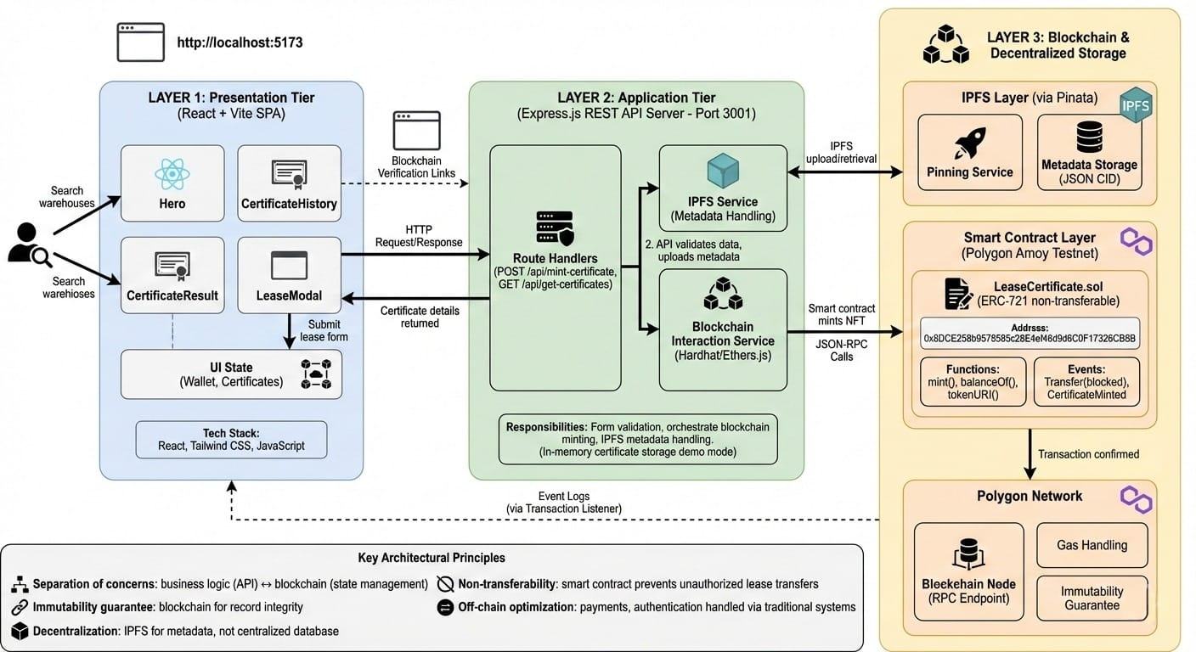

- Hybrid Web2/Web3 Architecture: The system bridges traditional web development (a React frontend and an Express.js REST API backend) with decentralized technologies. The backend API serves as the critical orchestration layer, handling data validation and abstracting complex blockchain interactions away from the client-side UI.
- Immutable and Decentralized Lease Records: Instead of relying solely on a centralized database, lease metadata (JSON) is stored decentrally via IPFS (using Pinata). The actual lease certificate is minted as a non-transferable ERC-721 NFT on the Polygon blockchain, ensuring the record is permanent and tamper-proof.
- Reactive Data Flow: The diagram illustrates a complete loop where user actions on the frontend trigger backend processes that change the blockchain state. The frontend then relies on transaction listeners to detect blockchain "Events" and update the UI dynamically with the new certificate details.

Conclusion

In conclusion, AtLease presents a transformative approach to warehouse leasing by replacing vulnerable paper-based systems with a secure, decentralized framework. By uniquely utilizing Soulbound Tokens (SBTs) on the Polygon blockchain, the project ensures that lease certificates are non-transferable and permanently tied to the rightful tenant, effectively eliminating risks of forgery and unauthorized subleasing. The strategic integration of IPFS for cost-effective data storage and a modular Node.js architecture creates a scalable, transparent, and tamper-proof ecosystem. Ultimately, AtLease demonstrates the practical utility of blockchain technology beyond finance, providing a reliable "single source of truth" that fosters trust, enhances security, and streamlines the future of digital asset management in the leasing sector.

